**PRE LAB 2**

**Exercise 1:**

library ieee;

use ieee.std_logic_1164.all;

entity PreEx1 is

    port(a, b, ci: in  std_logic;

            co, s: out std_logic);

end PreEx1;

architecture Full_Adder of PreEx1 is

begin

    s <= a xor (b xor ci);

    co <= (a and (b or ci)) or (b and ci);

end Full_Adder;

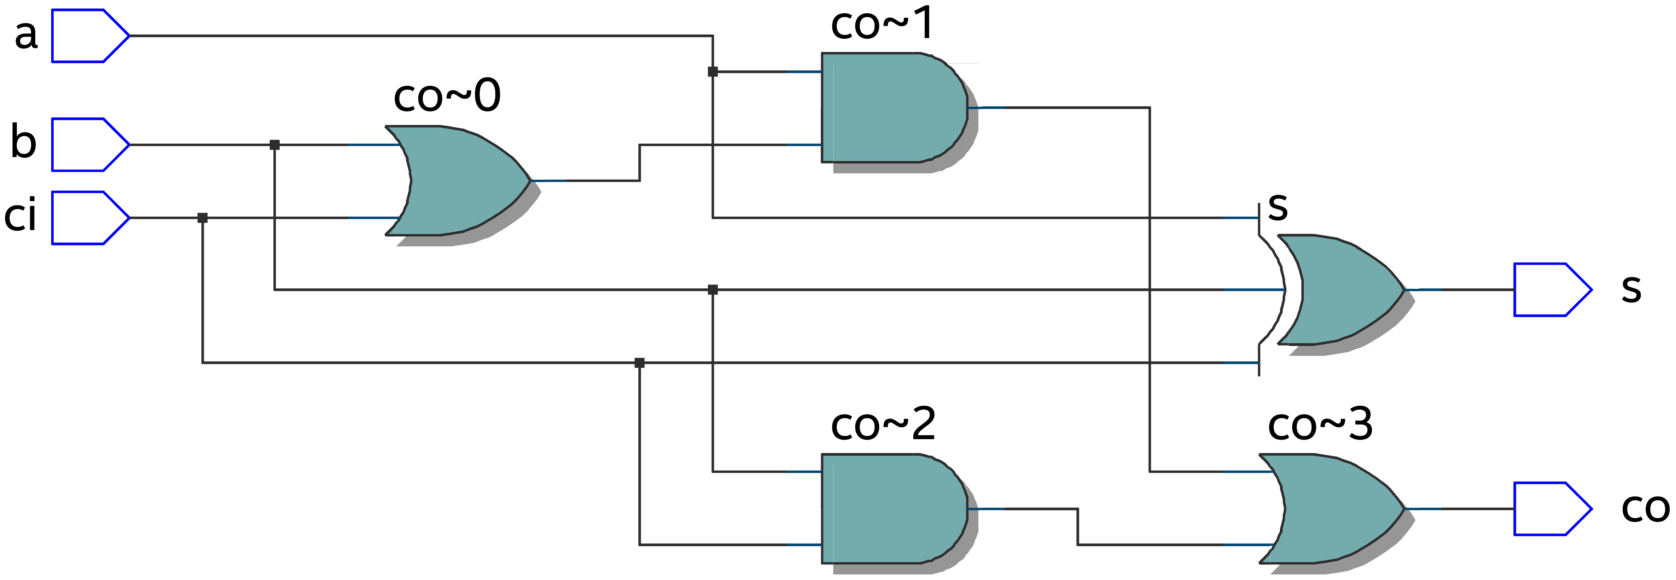

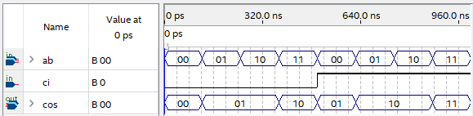

**Exercise 2:**

library ieee;

use ieee.std_logic_1164.all;

entity PreEx2 is

    port(    R,  S, CLK: in     std_logic;

         Rg, Sg, Qa, Qb: buffer std_logic);

end PreEx2;

architecture RS_Latch of PreEx2 is

begin

    Rg <= R and CLK;

    Sg <= S and CLK;

    Qa <= Rg nor Qb;

    Qb <= Sg nor Qa;

end RS_Latch;

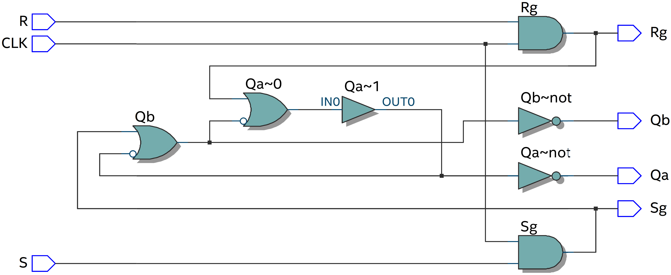

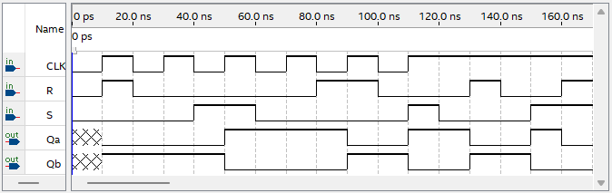

**Exercise 3:**

library ieee;

use ieee.std_logic_1164.all;

entity PreEx3 is

    port(        D, CLK: in     std_logic;

         Rg, Sg, Qa, Qb: buffer std_logic);

end PreEx3;

architecture D_Latch of PreEx3 is

begin

    Rg <= (not D) nand CLK;

    Sg <= D nand CLK;

    Qa <= Sg nand Qb;

    Qb <= Rg nand Qa;

end D_Latch;

